LINKEDIN JOB POSTING ANALYTICS 2023–2024
Project Documentation

1. Project Overview
Project Title
LinkedIn Job Posting Analytics Dashboard 2023–2024
Project Description
This project focuses on analyzing LinkedIn job posting data from 2023–2024 using Power BI. The main objective is to identify hiring trends, salary insights, remote work patterns, employment types, and company hiring activities.
The project uses a STAR SCHEMA data model and an interactive dashboard to support business analysis and decision-making.

2. Data Cleaning Documentation
Dataset Used
Source: https://www.kaggle.com/datasets/arshkon/linkedin-job-postings
- Main File Used: Fact_Postings.csv

Data Cleaning Objectives
The dataset was cleaned and transformed to:
- Remove unnecessary columns
- Fix missing values
- Standardize data formatting
- Convert timestamp values into readable dates
- Create clean dimension tables for analysis
- Improve dashboard performance

Data Cleaning Process
Step 1 — Import Dataset
The CSV dataset was imported into Power BI using Power Query.
Step 2 — Remove Unnecessary Columns
Unused columns were removed to simplify the analysis.
Removed columns include:
- description
- application_url
- posting_domain
- zip_code
- fips
- original_listed_time
- company_id (old ID)
- job_posting_url
- skills_desc
- currency
- compensation_type
- expiry
- closed_time

Step 3 — Remove Duplicate Records
Duplicate job postings were removed using:
- job_id
This ensures every job posting appears only once.

Step 4 — Handle Missing Values
Null values were cleaned and replaced.
Examples:
Column |  |  |  |  | Replacement
Work Type |  |  |  |  | Unknown
Experience Level |  |  |  |  | Not Specified
Remote Type |  |  |  |  | On-site
Views |  |  |  |  | 0
Applies |  |  |  |  | 0
Salary |  |  |  |  | 0

Step 5 — Convert listed_time to Date
The Unix timestamp column was converted into a readable date format.
Example:
- Original: 1712966400000
- Converted: 2024-04-13

Step 6 — Create New Columns
Additional calculated columns were created:
Remote Type
- Remote
- On-site
Date Columns
- Year
- Month
- Quarter
Step 7 — Build Dimension Tables
Separate dimension tables were created for:
Dimension Table |  | Purpose
Dim_Company |  | Company information
Dim_Date |  | Time analysis
Dim_Location |  | Geographic analysis

3. Exploratory Data Analysis (EDA)
The following business questions were analyzed:
Business Questions
1. Which companies post the most jobs?
Used to identify the most active recruiters.
2. Which locations have the highest hiring activity?
Used to determine high-demand hiring areas.
3. What employment type is most common?
Analyzed job distribution by:
- Full-time
- Contract
- Internship
- Part-time
- Temporary
4. How do hiring trends change monthly?
Used to analyze seasonal hiring activity.

5. What experience levels are most in demand?
Compared:
- Entry level
- Associate
- Mid-Senior level
- Director
- Executive
6. What is the distribution of remote vs on-site jobs?
Used to evaluate remote work opportunities.

4. Key Metrics and Measures (KPIs)
The dashboard includes the following KPIs:
KPI | Meaning
Total Jobs | Overall hiring activity
Average Salary | Salary trend analysis
Remote Job % | Percentage of remote jobs
Total Applies | Total job applications
Total Views | Total posting views

DAX Measures Used
Total Jobs
Total Jobs = COUNT(Fact_Postings[job_id])
Average Salary
Average Salary = AVERAGE(Fact_Postings[normalized_salary])
Remote Job %
Remote Job % =
DIVIDE(
CALCULATE(COUNT(Fact_Postings[job_id]), Fact_Postings[Remote Type] = "Remote"),
COUNT(Fact_Postings[job_id])
)
Total Applies
Total Applies = SUM(Fact_Postings[applies])
Total Views
Total Views = SUM(Fact_Postings[views])

5. Data Model (STAR SCHEMA)
The project uses a STAR SCHEMA model.
Fact Table
Fact_Postings
Contains:
- Job postings
- Salary
- Views
- Applications
- Work type
- Experience level
- Remote type

Dimension Tables
Dim_Company
Contains:
- company_id
- company_name
Dim_Date
Contains:
- Date
- Year
- Month
- Quarter
Dim_Location
Contains:
- location_id
- Location

Relationships
From | To | Relationship
Fact_Postings → Dim_Company | company_name | Many-to-One
Fact_Postings → Dim_Date | Date | Many-to-One
Fact_Postings → Dim_Location | Location | Many-to-One
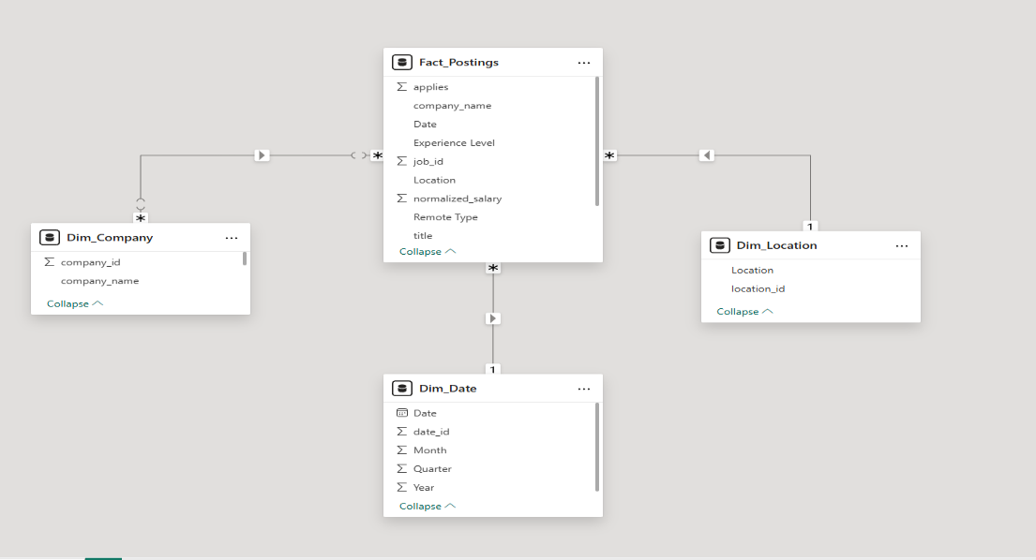

6. Dashboard Layout Draft
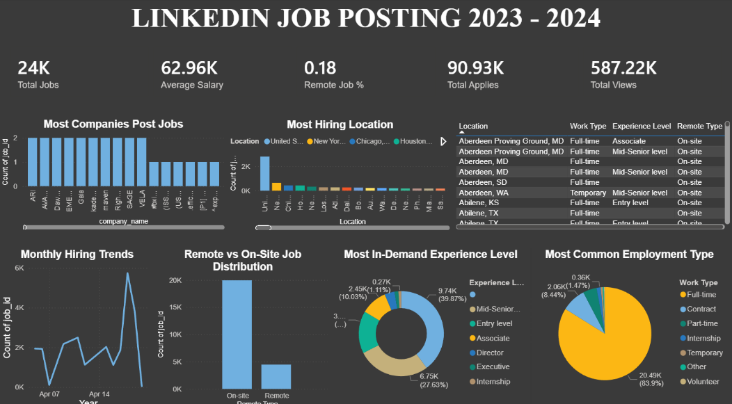
The dashboard was designed as a single-page executive overview for easy monitoring and analysis.

Dashboard Title
LINKEDIN JOB POSTING 2023–2024

Dashboard Components
KPI Cards
Located at the top section:
- Total Jobs
- Average Salary
- Remote Job %
- Total Applies
- Total Views

Visualizations Used
1. Most Companies Post Jobs
Type:
- Bar Chart
Purpose:
- Identify companies with the highest number of job postings.

2. Most Hiring Location
Type:
- Bar Chart
Purpose:
- Identify geographic areas with the highest hiring activity.
3. Monthly Hiring Trends
Type:
- Line Chart
Purpose:
- Analyze hiring activity over time.

4. Remote vs On-site Job Distribution
Type:
- Column Chart
Purpose:
- Compare remote and on-site jobs.

5. Most In-Demand Experience Level
Type:
- Donut Chart
Purpose:
- Analyze demand by experience level.

6. Most Common Employment Type
Type:
- Pie Chart
Purpose:
- Compare employment types.

7. Job Details Table
Type:
- Table Visual
Contains:
- Location
- Work Type
- Experience Level
- Remote Type
Purpose:
- Display detailed job posting records.

7. Dashboard Design Reference
The dashboard uses:
- Dark theme layout
- White typography for readability
- Interactive visuals
- Business-focused KPI cards
- Single-page executive design
The dashboard includes:
- KPI summary cards
- Trend analysis
- Employment analysis
- Geographic insights
- Remote work analysis

8. Insights and Findings
Key Findings
1. Full-time jobs dominate the dataset
Most job postings are full-time positions.
2. On-site jobs are more common than remote jobs
The majority of postings are still on-site.
3. Mid-Senior level positions are highly demanded
Companies frequently search for experienced professionals.
4. Hiring activity changes over time
Monthly hiring trends show fluctuations across different periods.
5. Some companies post significantly more jobs
A small number of companies contribute a large portion of total postings.

9. Conclusion
This project successfully transformed raw LinkedIn job posting data into a clean and interactive Power BI dashboard.
The dashboard helps users:
- Understand hiring trends
- Analyze job demand
- Explore salary insights
- Evaluate remote work opportunities
- Monitor employment patterns
The project demonstrates practical skills in:
- Data Cleaning
- Power Query
- Data Modeling
- DAX Calculations
- Dashboard Design
- Business Analytics

10. Tools Used
Tool | Purpose
Power BI | Dashboard and analytics
Power Query | Data cleaning and transformation
DAX | KPI calculations
CSV Dataset | Data source

